SM 121b-Module Learning Guide

Faculty Name: |  |  | Aron Janssen, MD  Kaitlyn Kunstman, MD |  |  | Preferred Method of Contact: |  |  | Email
Phase: | 1b | Module: |  | Psych | Element/Thread: |  | SM | Lecture #, Week #, or Date: |  | 10/13/2020
Learning Activity Title: |  |  |  | Gender Development & Sexuality
Learning Activity Type: |  |  |  | Lecture
Contact Info: |  |  |  | Phone: |  | Email: |  |  | Campus Address:
ajanssen@luriechildrens.org
k-kunstman@northwestern.edu

Learning Objectives:
1). Distinguish between different aspects of gender, including gender expression, gender identity, and gender behaviors, and sexuality, including sexual orientation, sexual identity, and sexual behavior. [MKS-1a, CES-1]

2). Recognize the historical evolution of psychiatric diagnostic classification of gender and sexuality phenomena and how that impacts clinical care across disciplines [CES-2]

3). Construct a gender development timeline, including when children begin to understand sex differences and form their own gender identity [MKS-1a]

4). Describe gender dysphoria as it may occur in the peripubertal child [MKS-1a]

5). Identify common mental health comorbidities in individuals with gender dysphoria [MKS-3a]

6). Introduce the concept of gender transition, including the concept of a social transition and common medications used in transgender health [MKS-1e, MKS-1c, PBMR-1]

Optional Preparatory Work:
Chen D, Hidalgo MA, Leibowitz S, Leininger J, Simons L, Finlayson C, Garofalo R (2016) Multidisciplinary care for gender-diverse youth: a narrative review and unique model of gender-affirming care, Transgender Health 1:1, 117–123, DOI: 10.1089/trgh.2016.0009.

Affirmative Mental Health Care for Transgender and Gender Diverse Youth: A Clinical Guide. Aron Janssen and Scott Leibowitz. 2018. Springer International Publishing. https://doi-org.ezproxy.galter.northwestern.edu/10.1007/978-3-319-78307-9

Drescher, J. 2010. Queer Diagnoses: Parallels and Contrasts in the History of Homosexuality, Gender Variance, and the Diagnostic and Statistical Manual. Archives of Sexual Behavior 39:427-460. DOI: 10.1007/s10508-009-9531-5

The Gender Unicorn: http://transstudent.org/gender

Outline:
- Overview of relevant terminology
- Critique of DSM and historical context
- Timeline of gender identity development
- Gender Dysphoria
- Introduction to Gender Transition
- Multidisciplinary Care for Gender-diverse Adolescents

Overview of Relevant Terminology:

Natal Sex: refers to genotypic and phenotypic physical characteristics, including external genitalia and internal gonads, used to assign sex at birth and is developed by hormone levels, receptors, and chromosomes

Gender Role: refers to societal expectations of how one conducts themselves, conventionally regarded as masculine or feminine, in such areas as dress, speech, and behavior

Gender Expression: refers to how someone portrays their subjective sense of their gender in areas as dress, speech, mannerisms, and behavior

Gender Identity: refers to a person’s personal sense of gender

Gender Nonconformity: refers to variation in gender role behaviors from conventional norms

Gender Incongruence: identity phenomenon when one’s gender identity and natal sex are not congruent with one another

Gender Dysphoria: subjective distress experienced by those whose gender identity is not aligned with their natal sex. The term is also used to describe a diagnostic classification within the DSM5 for individuals meeting a certain number of criteria among two developmental subtypes: Childhood and Adolescent/Adults

Gender Transition: process by which an individual begins living in their affirmed gender role encompassing social and/or medical transition which may or may not include hormonal and/or surgical treatment; highly individualized process

Transgender: individuals whose gender identity is incongruent with their natal sex, many of whom seek gender affirmation through social transition, medical and/or surgical interventions to align their identity with their physical selves. This term can also be used as an umbrella capturing all individuals across the gender spectrum

Genderqueer: colloquial term used to indicate those whose gender identity or role does not conform to the societal binary

Sexual Orientation: the pattern of emotional, romantic, and/or sexual attraction to other people

Sexual Identity: an individual’s sense of self as it may relate to their sexual orientation, sexual behavior, personal identity, and social role

Sexual Behavior: the sexual acts in which an individual participates, which are not necessarily always synchronous with their sexual orientation or their overall sexual identity

Critique of DSM and historical context:

Key historical facts regarding the evolution of gender and sexuality as diagnoses within the DSM will be reviewed including:
- 1973 - removal of homosexuality from DSM (replaced by Sexual Orientation Disturbance)
- 1980 - inclusion of Gender Identity Disorder of Childhood and Transsexualism; removal of Sexual Orientation Disturbance which was then replaced by Ego Dystonic Homosexuality
- 1987 – Ego Dystonic Homosexuality removed from DSM-III-R (due to lack of empiric evidence); addition of Gender Identity Disorder of adolescence and adulthood, nontranssexual type
- 1994 – re-classification as Gender Identity Disorder with different criteria for children vs adolescents and adults
- 2011 - WPATH standards of care, 7th edition published
- 2013 – Removal of Gender Identity Disorder from DSM-5 and addition of Gender Dysphoria

Timeline of Gender Identity Development:

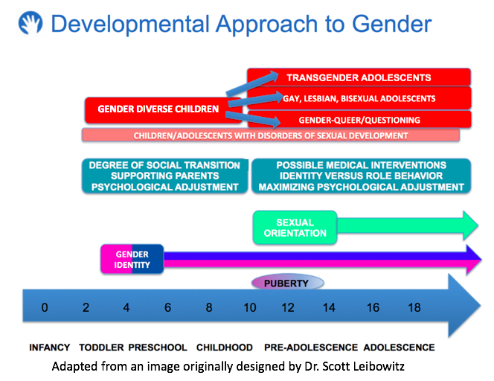

- By age 18-24 months, children develop the ability to label gender
- Between 2-4 years most children can recognize sex differences and use gendered pronouns
- By age 5-6 years, most children report stable and consistent gender identity (i.e. gender constancy)
- Many children experiment with gender expression and roles in terms of play, dress, and peer affiliation and this is a NORMAL part of development
- However, some children exhibit persistent and insistent nonconforming behaviors and expression and may go on to develop gender dysphoria

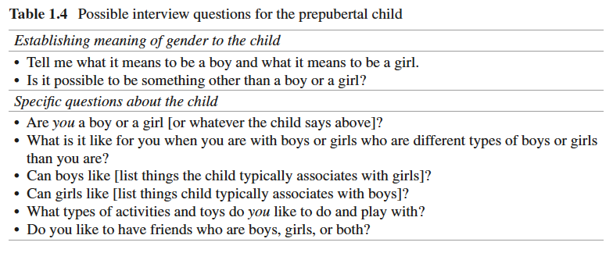
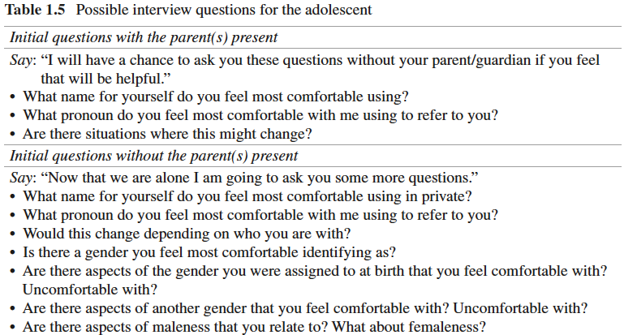
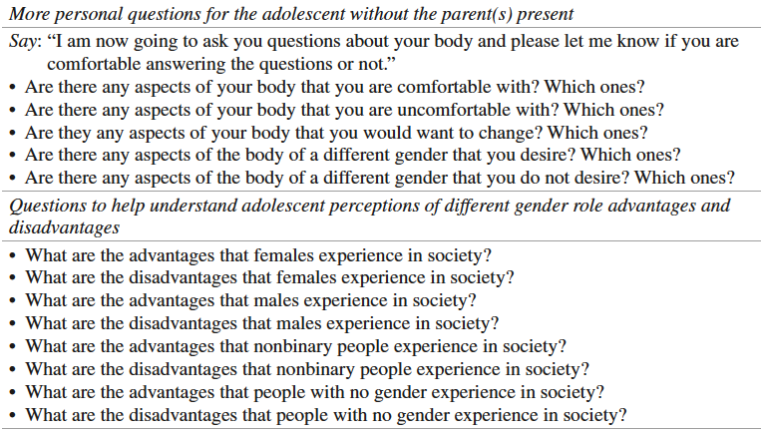

Gender Dysphoria:

DSM-5 Diagnostic Criteria:
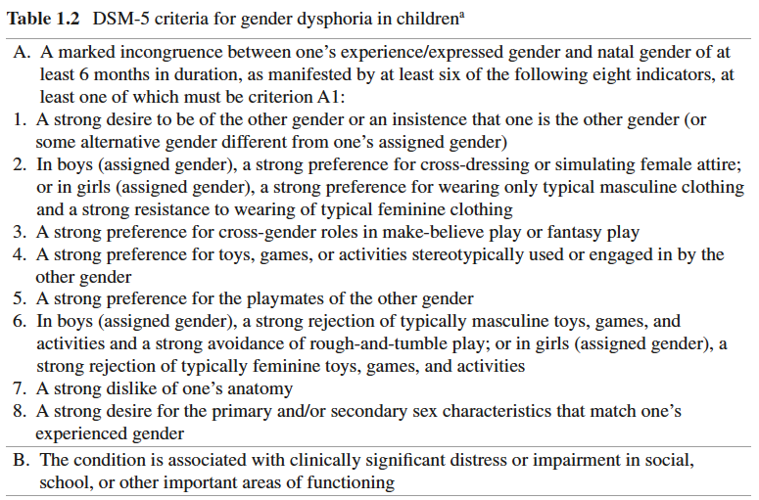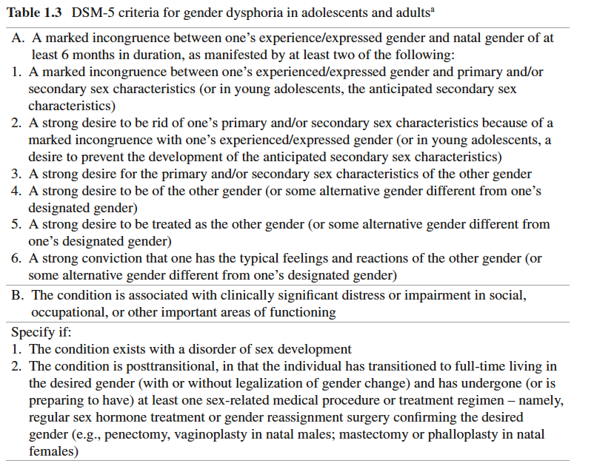

Epidemiology:
Estimates from population based studies between 2012-2017 ranged from 0.5-2.7%
- 2011 population based study in middle-school aged children in San Francisco: 1.3% identified as transgender (0.6% of those aged 11 or younger and 1.7% by age 13)
- 2016 population based study in high-school aged children in Minnesota: 2.7% identified as transgender or gender diverse
- The Williams Institute 2016 Data: 1.4 million US adults identify as transgender (0.6% of the population)
  - Age 18-24: 0.66%
  - Age 25-64: 0.58%
  - Age 65+: 0.50%
- 2014-2016 CDC Behavioral Risk Factor Surveillance System (survey of adults):
  - 0.48% identified as transgender with another 0.60% answering that they did not know or were not sure; 0.24% further identified as male-to-female, 0.14% as female-to-male, and 0.10% as gender nonconforming

Course:
According to one 2008 study of children with gender dysphoria by Wallien and Cohen-Kettenis, there may be up to a 15-27% persistence of gender dysphoria into adolescence.

What factors may help predict persistence of gender dysphoria into adolescence/adulthood?
- A higher intensity of childhood gender dysphoria
- A tendency to assert their gender cognitively versus affectively (e.g. “I am a boy” vs “I feel like a boy”)

Gender dysphoria that continues into adolescence is unlikely to subside and for many may intensify with pubertal changes.

Affirming the gender identity/expression of youth is important, even if many children with gender dysphoria will not go on to develop into transgender youth.

Psychiatric Comorbidities:
Gender diverse individuals have higher rates of:
- anxiety
- depression
- ADHD
- autism spectrum disorders
- low self-esteem and decreased sense of wellbeing
- family and/or peer rejection, social isolation, loss of financial support
- self-injury, suicidal ideation, and suicide attempts
- physical, sexual, emotional, and/or verbal abuse, harassment and/or assault
- unemployment, homelessness
- substance use/abuse

Introduction to Gender Transition:

Every individual will have their own approach to their gender transition which may include components of a social and/or medical transition. Social gender transition is the process by which an individual transitions towards living as a gender different from the one assigned at birth. This process may include using a different name and/or set of pronouns as well as changes to their gender expression or gender role. Medical gender transition may include pubertal suppression, gender affirming hormone replacement therapy, and gender affirming/confirming surgery. A brief overview of medical options for gender transition will be reviewed during the lecture.

